**Introduction**

In Project 1, an empty snow globe was constructed. Project 2 focused on the content found within the snow globe, the snow and the scene. The snow would be constructed of small globes impacting the sides of the snow globe in agitation. The scene consists of a procedural city and height map both textured to simulate realism. A procedural city is a way of modeling a city using an algorithmic approach. A simple randomization of heights and widths of a cube allows for buildings to be made in different dimensions simulating the look and feel of a real city. The height map terrain was generated using a standard terrain height map procedure. Initially, it was thought that the best implementation would be a diamond square based height map, however this proved to be ineffective. The base was textured with wood grain texture and lightened and darkened to aid in effect. The background was changed to highlight the features of the snow globe and to add depth to the image. The final goal of Project 2 was to create a realistic snow globe that contains snow, a procedural city, and a height map terrain on a wooden base.

**Methods**

Development of the project was done in four phases. Each phase progressed the project by implementing key elements and allowing for those implementations to be done incrementally. By using this approach, each element could be focused on individually and finalized before the next element was introduced.

The City

The first phase of the project was a procedural city. The base implementation of a procedural city was based on a tutorial found at [learningthreejs.com](http://learningthreejs.com). It outlined how a base procedural city could be implemented using a simple for loop. The loop is initiated with an simple THREE.BoxGeometry( 30,30,30). The shape was then generated and altered 35 times using random scaling and placement variables to allow for the procedural city framework to be built. The city then had to be lowered to the snow globe base to allow for the city to look like it is embedded on the base. Once lowered to the snow globe base, a base color of red was applied to the city to signify it was ready for textures. Preparing the surface of the buildings allowed for future applications of texture and lighting to be developed while assuring all the necessary elements were developed in the allotted time for the project.

The Terrain

Phase two focused on the development of the height map terrain for the snow globe scene. The initial development of the scene involved implementation of the diamond square algorithm. This required the construction of multiple functions leveraged from a previously developed diamond square height map. After testing of this method, it became clear that a height map based off a height map image would best suit the needs of the project and would allow for easy manipulation for future plans. This method of implementing a height map required use of a height map jpg and processed the height using a getHeightData(img,scale) function which contained an algorithm that processed the height map image to produce z value coordinates. The z value coordinates were then applied to the height map using a for loop. The primary difference in this implementation compared to previous implementations was that the height map was applied to a THREE.CircleGeometry. This was done by making sure the Circle had enough vertices to allow for the processing and was based on the size of the image minus 1.

The Snow

Creating snow was the third phase of project. Initial implementation involved the usage of Three.js particles but were deemed unattractive for the desired goal. This was instead implemented using 450 THREE.SphereGeometry(10, 20, 20) randomly scattered upon the surface of the terrain. This established an inactive baseline for the snow. To move the snow around the globe, the position of the snow balls were altered within the programs rendering function. The movement of the spheres was dictated based on agitation of the globe. The snow balls are one the texture map when inactive, they are rotating in circular motions when a medium point of agitation, and at initial agitation are put on a turbulent motion. The Day time element is used to progress movement with application of trigonometric functions to simulate spherical bounds. A code example seen in **Formula Example 1** shows one of the methods used to create the spherical rotation of snow balls. An application of collision detection was desired but it was unable to be implemented in time allowed.

sphere.rotation.x = -580 * Math.sin( timer + i );

sphere.position.z =-580 * Math.cos( timer + i );

sphere.position.y = -580 * Math.cos( timer + i + 2.2) + 420;

sphere.rotation.x = -580 * Math.sin( timer + i );

sphere.position.z =-580 * Math.cos( timer + i );

sphere.position.y = -580 * Math.cos( timer + i + 2.2) + 420;

Formula Example 1: Example implementation of snow particle rotation

Texturing

Once all the key elements had been implemented, it was necessary to texture and stylize the elements. All elements were covered with textures and applied the necessary lighting and environment that will enhance the scene. The skybox was changed to a clouds in the sky effect to enhance the overall glass effect of the snow globe and allow for some interesting lighting effects. The procedural city was mapped with varying building textures chosen by set of if loops randomizing which building gets what texture in relation to how previous cities had been textured. A code example seen in **Formula Example 2** shows the if loop sections used to create differing building textures. The height map terrain and snow balls were textured with a snow texture applied with a mesh that increases reflectivity and allows for the snow to almost glisten. The base was textured with a wood grain texture. The overall lighting was enhanced with the mesh textures rather than ambient lighting.

if(i%2 == 0){

var mesh3 = new THREE.Mesh( geometry3, new THREE.MeshBasicMaterial( {map: buildingTexture} ) );

}

else if (i%3 ==0){

var mesh3 = new THREE.Mesh( geometry3, new THREE.MeshBasicMaterial( {map: buildingTexture3} ) );

}

else{

var mesh3 = new THREE.Mesh( geometry3, new THREE.MeshBasicMaterial( {map: buildingTexture2} ) );

}

Formula Example 2: Example implementation of texturing buildings

**Testing and Verification**

Each section of the implementation had to be fully tested to assure each element had been correctly applied and that the effects would be in the correct position in relation to the other elements in the scene. The testing procedure included implementing a base form of the idea and then elements were tweaked to produce the desired overall effect. Final tweaks were made during texturing to enhance the textures and to create a better overall snow globe.

**Phase 1**

The first step in this project was implementing the procedural city. The first thing to do was to put a cube on the screen. This could then be used to create the base procedural city implementation. The cubes altered by the procedural city loop were then lowered to become flush with the base of the snow globe. Once a visual confirmation of correctness was completed, as seen in **Figure 1** below, the procedural city was slightly modified to increase number of buildings and variation in height, width, and depth.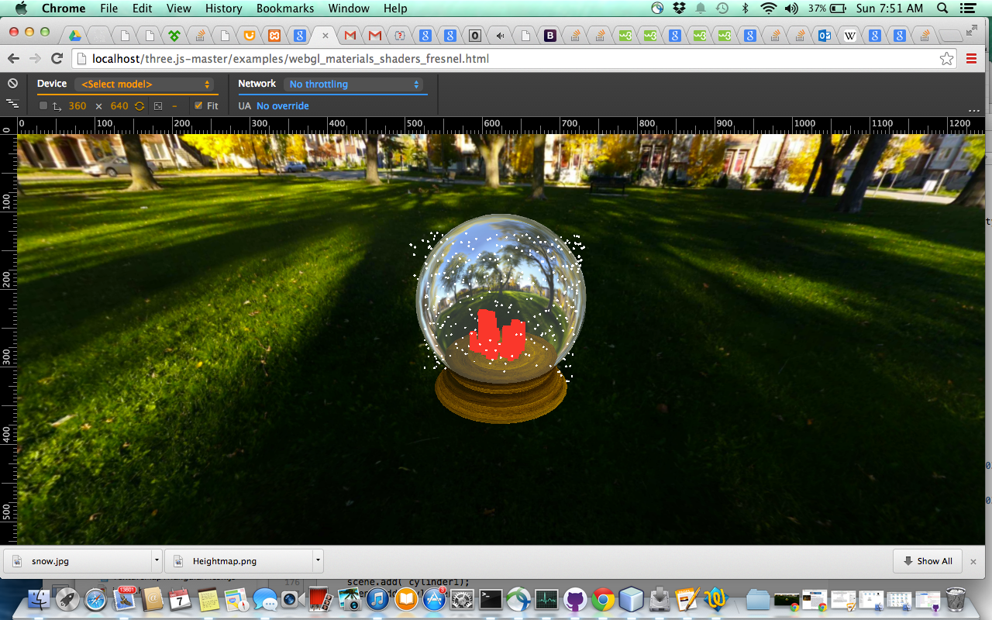

Figure 1: Base implementation of procedural city after visual confirmation of correctness.

**Phase 2**

Creating the terrain was the second step. This was initially completed using a diamond square algorithm. However, the randomness produced by the base algorithm created sections that were difficult to align to the base. There were also sections that broke when z heights were applied to the Three.CircleGeometry, resulting in broken segments. An example of these issues can be seen in **Figure 2** below.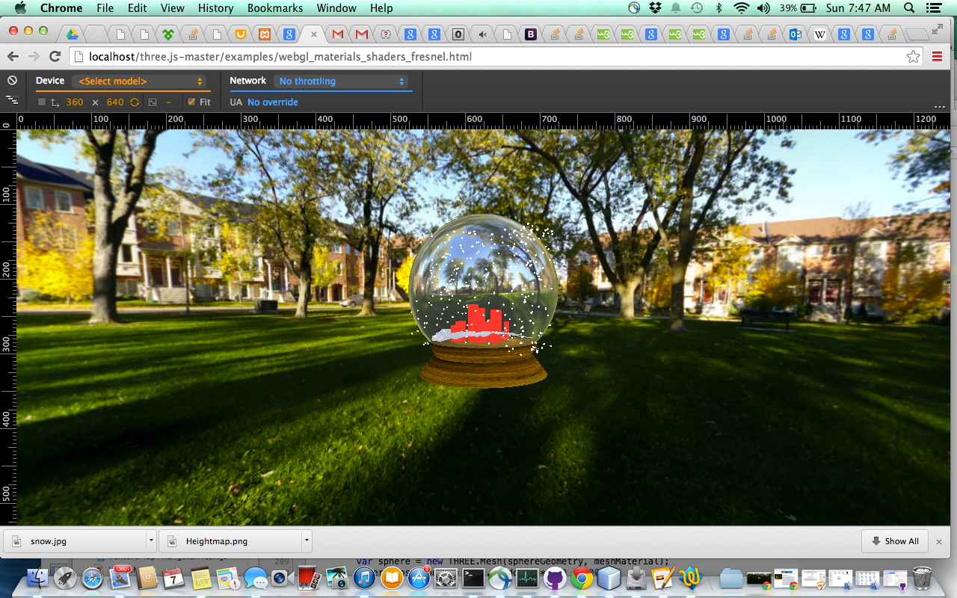

Figure 2: Base implementation of diamond square height map.

The visual issues created by the diamond square implementation were solved with the implementation of a texture based height map. This allowed for pigment alteration to the base image to create a scene that would adequately suit the parameters of the snow globe and not distort the THREE.CircleGeometry shape. This was then lowered to the snow globe based and positioned in relation to the previously built elements of the snow globe. This can be seen in **Figure 3** below.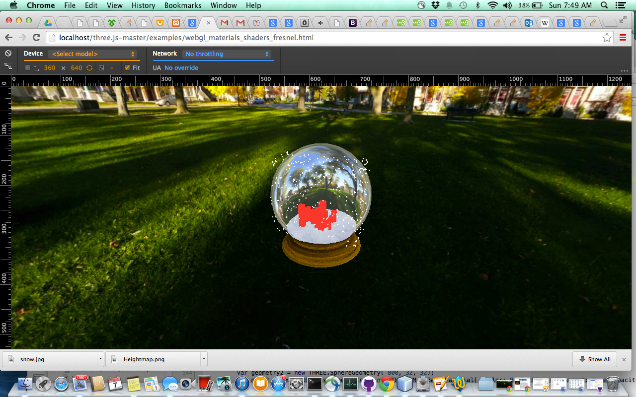

Figure 3: Base implementation of texture based height map after visual

confirmation of correctness.

**Phase 3**

The implementation of the snow element of the snow globe required numerous amounts of tweaks to perfect the effect, the timing of the movement, and the spacing of the snow balls. **Figures 1, 2, and 3** show the base implementation of snow that produced a cylinder of snow balls. This was caused due to a miscalculation of the points on a sphere due to a switch of the a sin calculation of the z coordinates instead of a cos calculation. With a generous amount of research and modifying of trigonometric functions, an adequate rotation of snow flakes was produced within the bounds of the sphere. This can be seen in **Figure 4**.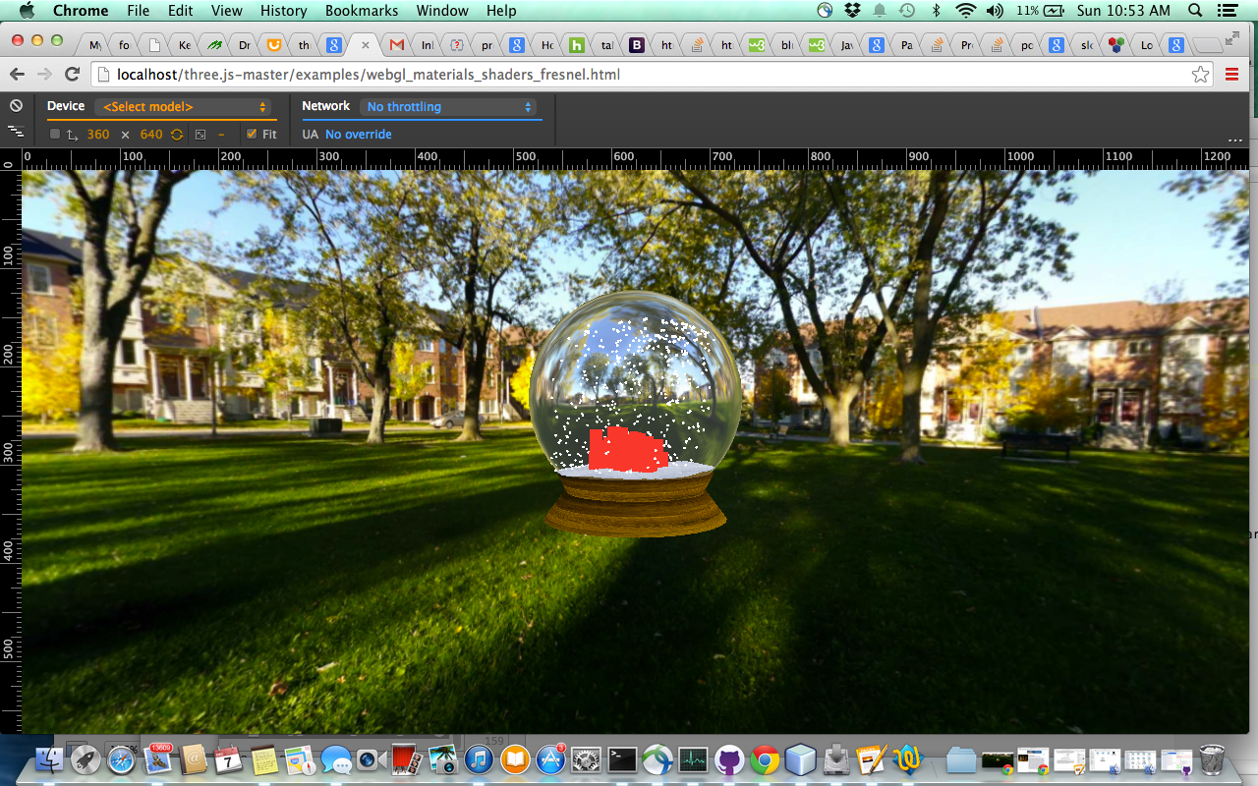

Figure 4: Spherical rotation of snow balls initially implemented.

**Phase 4**

Once the base implementation of all the elements were implemented, final touches to the scene could be added. Initial texturing could be completed to add to the overall completeness of the snow globe. First, a building texturewas applied to the procedural city and a snow texture was added to the meshes of the snow and terrain. This established an initial understanding of how each item could be textured and allowed for ideas on what graphical tweaks needed to be made. This first step could be seen in **Figure 5**.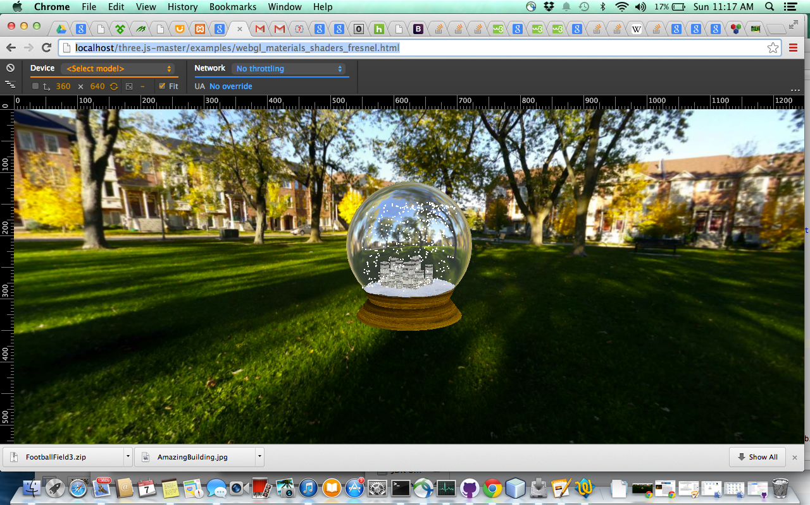

Figure 5: Base textures applied to snow globe elements.

The initial implementation of textures made many graphical issues pop out. First, the background created by the skybox really did not fit the overall feeling of the snow globe. It also did not allow for the enhanced lighting that was required to accentuate the glass effects created by the snow globe. All textures were then altered to improve reflective properties and increases to ambient and specular coloring were applied. This created a near final image of a snow globe, as seen in **Figure 6**, but made the city look a little flat and highlighted issues with the movement of the snow.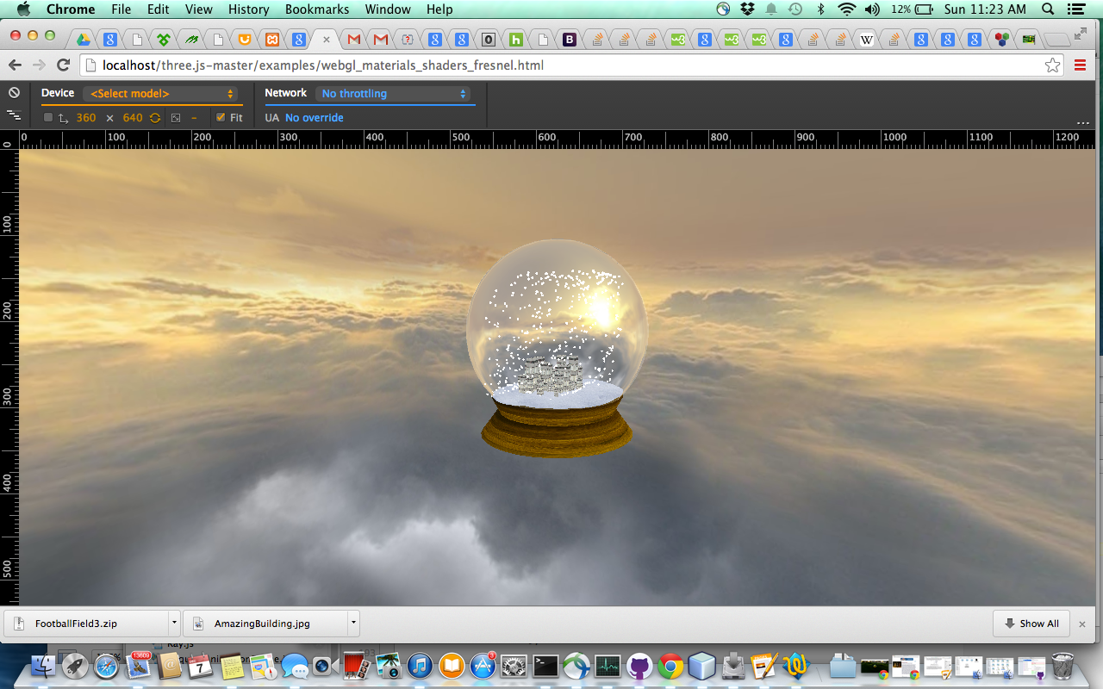

Figure 6: Skybox images switched out and enhanced textures app

lied to snow globe elements.

Final alterations were made to the snow globe adding an enhanced snow ball rotations and differing textures to buildings. These had to be incrementally tested. Final implementations were tested and altered to increased randomness at load and to stream line the overall functioning and load time of the snow globe. A final visual confirmation was made, seen in **Figure 7**.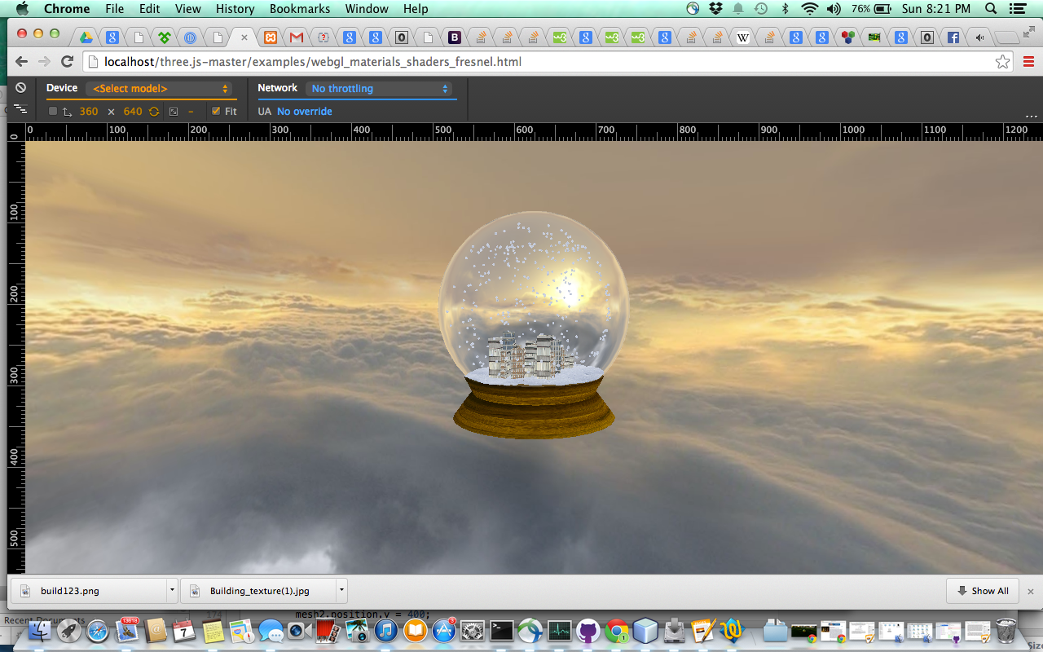

Figure 7: Final implementation of snow globe.

**Analysis**

Each element within the snow globe had to be carefully paired and related to the other elements in the snow globe. The elements had to have specialized height adjustments made to the y position to assure all the items aligned appropriately. All movements and positioning had to be made in relation to all the elements and the effects of all the elements. The implementation required a lot of tuning and manipulation to assure all the elements aligned appropriately.

The most complex portion of the implementation had to be the positioning of the snowballs to simulate a spherical rotation. Various manipulations had to be made to trigonometric functions to assure that the sphere was filled with snowballs floating within the sphere. While a collision detection system would have aided in this process, it was determined early on that collision detections would have to wait till Phase 3 of the snow globe project. Due to this lack of detection, the alignment of the snowballs had to be implemented and tested numerous times to assure the snow balls were staying within the sphere and that the sphere had adequate coverage of the spheres. The primary theme in the snow globe project was relationships between geometric positioning of the elements, each elements tying to the previous and aligning correctly in relation to each other.

**Interpretation**

The primary success of this project was implementing multiple different techniques within a single project without a noticeable amount of lag for the user. Each element was carefully orientated to every other element making every alignment very precise. The initial goal of creating a realistic looking snow globe was achieved but many elements could still be added to enhance the visual effects of the scene.

There are a few issues that could be improved upon in a third phase of implementation. The snow globe elements still seem a little flat. Bump mapping and additional advanced texturing could be applied to the snow globe increase depth to the snow globe and shadowing could be added as well. Lighting effects within the snow globe could also be improved upon. For example, increasing the reflectivity of the globe would enhance overall realism of the snow globe. There are also numerous post production effects that could be added, such as collision detection, animation, and music. Without these additions the snow globe lacks a bit of realism but it does achieve the overall project goal.

The project was a success in creating a realistic snow globe and allowed for a full understanding and comprehension of Three.js and it capabilities. It can be quite addicting to toggle attributes trying to find the perfect combination for the Three.js scene. The snow globe project creates a pleasing representation on how all the different techniques learned during the course can produce a pretty nice 3D scene.

**Bibliography**

Angel, E., & Shreiner, D. (n.d.). Interactive computer graphics: A top-down approach with WebGL (7th ed.).

Dirksen, J. (2013). Learning Three.js the JavaScript 3D library for WebGL : Create and animate stunning 3D graphics using the open source Three.js JavaScript library. Birmingham, UK: Packt Pub.

Dirksen, J. (2014). Three.js essentials create and animate beautiful 3D graphics with this fast-paced tutorial. Birmingham, UK: Packt Pub.

Etienne, J. (n.d.). Learning Three.js. Retrieved November 5, 2014.

Li, H., Leung, K.-S., Nakane, T., & Wong, M.-H. (2014). iview: an interactive WebGL visualizer for protein-ligand complex. BMC Bioinformatics, 15, 56. Retrieved from <http://go.galegroup.com.weblib.lib.umt.edu:8080/ps/i.do?id=GALE%7CA361370999&v=2.1&u=mtlib_1_1195&it=r&p=AONE&sw=w&asid=7344158067bc6f64c0c4acd3700e5a99>

Mr & Mrs. (n.d.). Retrieved November 5, 2014.

Mr Doob. (n.d.). Retrieved November 5, 2014.

Parisi, T. (2014). Programming 3D applications with HTML5 and WebGL. Sebastopol, CA: O'Reilly Media.

Three.js r69. (n.d.). Retrieved November 4, 2014.

WebGL With Three.js: Shaders - Tuts Code Tutorial. (n.d.). Retrieved November 3, 2014.